GRADING & REPORTING
Grades give students, parents, teachers, Academy leaders and Founders clear information about the progress of students. Teachers in the Primary division determine this grade by considering a broad range of assessments: the results of recent quizzes or tests; the quality of work completed in students’ books; the quality of homework; the results of practical assessments; the results of assessed presentations or project work. At Middle Secondary, these grades will reflect students' achievement in summative assessments which can be formed by in class assessments etc. For DP subjects in which results are mainly determined based on examinations and assignment work completed, however, this may also reflect in class summative assignment and ongoing end of unit assessments.

MODERATION
As much as possible, all summative assessments will be moderated prior to grading. At BGA we view moderation as a method of facilitating accurate assessment.
All summative assessments/exams can be moderated in the following manner but subject to HoDs’ final decision:
● Teachers should exchange a “low”, “medium” and “high” sample for a colleague(s) to moderate
● Teachers should not reveal to their colleague the grades they have given the samples, this will ensure a more authentic moderation process
● Following discussion of the moderation, teachers record the original grade or the moderated grade appropriately

Departments can decide the exact blend of assessments which come together to form the report grade, and should expect for this to triangulate with student performance observed in learning walks, book scrutinies, observations and - most importantly - in summative assessments and/or exams during the two assessment cycles. The termly grade should be arrived at from a best-fit approach.
In the IB Diploma, the grades are determined by a combination of different component grades, some of which are term or end of year examinations. These components are marked with component-specific criteria.
Report dates are as follows:
● Assessment Cycle 1: 30 January 2025
● Assessment Cycle 2: 20 June 2025

Primary

Achievement:
Teachers make professional evaluations regarding students’ achievement against the knowledge, skills and levels of the Cambridge Curriculum. The evaluations are made using the following categories;
Grade | Characteristic
Exceeding | The student is consistently demonstrating knowledge, skills, and conceptual understanding which is significantly above grade level expectations.
Applying | The student is demonstrating knowledge, skills, and conceptual understanding which are above grade level expectations.
Meeting | The student is demonstrating knowledge, skills, and conceptual understanding which are in line with grade level expectations.
Approaching | The student is demonstrating knowledge, skills, and conceptual understanding which are approaching but not yet consistently meeting grade level expectations.
Beginning | The student is in the early emergent stage of knowledge and skill development and has not yet demonstrated grade-level achievement.

Attitude for Learning Grades provide an opportunity for teachers to communicate to students and parents about levels of effort, engagement and productivity in lessons and homework tasks. A simple Excellent, Good, or Working Towards is entered into EduPages to communicate if the student is not yet meeting, is meeting or is exceeding the teacher’s expectations.
Attitude to Learning:
In addition to reporting on student achievement in each subject, a student’s Attitude to Learning is also reported on using the following categories:
Grade | Characteristic
Excellent | A student who always; Seeks challenges. Takes responsibility for their learning. Is collaborative. Is engaged. Is an active participant. Embodies BGA’s core values. Is a reflective learner. Is punctual and well equipped for learning.
Good | A student who mostly; Seeks challenges. Takes responsibility for their learning. Is collaborative. Is engaged. Is an active participant. Embodies BGA’s core values. Is a reflective learner. Is punctual and well equipped for learning.
Working Towards | A student who sometimes; Seeks challenges. Takes responsibility for their learning. Is collaborative. Is engaged. Is an active participant. Embodies BGA’s core values. Is a reflective learner. Is punctual and well equipped for learning.

Secondary
Achievement:
In the Diploma Programme, projected grades are entered at various points in keeping with application deadlines for different countries and are mainly used for applications to further study. For the predicted grade, four assessment points are used during the programme (January year 1, June year 1, January year 2 and March year 2 after the mock examinations. The programme coordinator and the teacher will then determine the projected grade a student could achieve.
DP1 and DP2 Points/Projections
Teachers make professional evaluations regarding students’ achievement against the knowledge, skills and levels of the IB curriculum. The evaluations are made using the following categories:
IB Grade | 1 | 2 | 3 | 4 | 5 | 6 | 7

Grades 6 to 8
Leave achievement levels empty
Grades 9 to 10
Teachers make professional evaluations regarding students’ achievement against the knowledge, skills and levels of the IB curriculum. The evaluations are made using the following categories:
IGCSEs | A | B | C | D | E | F | G

Attitude for Learning Grades provide an opportunity for teachers to communicate to students and parents about levels of effort, engagement and productivity in lessons and homework tasks. A simple Excellent, Good, or Working Towards is entered into EduPages to communicate if the student is not yet meeting, is meeting or is exceeding the teacher’s expectations.

Attitude to Learning:
In addition to reporting on student achievement in each subject, a student’s Attitude to Learning is also reported on using the following categories:
Grade | Characteristic
Excellent | A student who always; Seeks challenges. Takes responsibility for their learning. Is collaborative. Is engaged. Is an active participant. Embodies BGA’s core values. Is a reflective learner. Is punctual and well equipped for learning.
Good | A student who mostly; Seeks challenges. Takes responsibility for their learning. Is collaborative. Is engaged. Is an active participant. Embodies BGA’s core values. Is a reflective learner. Is punctual and well equipped for learning.
Working Towards | A student who sometimes; Seeks challenges. Takes responsibility for their learning. Is collaborative. Is engaged. Is an active participant. Embodies BGA’s core values. Is a reflective learner. Is punctual and well equipped for learning.

Two reports will be issued during the academic year - one per assessment cycle our letter to parents and students
In the reports, teachers comment on the student’s achievement level and how they can improve for specific strands of a specific criterion. In addition to this, regular feedback will be available in their notebooks, ManageBac for IB DP students, and/or Google Classroom or SeaSaw for Primary.

Examples of writing subjects specific strength and areas for development
Secondary examples
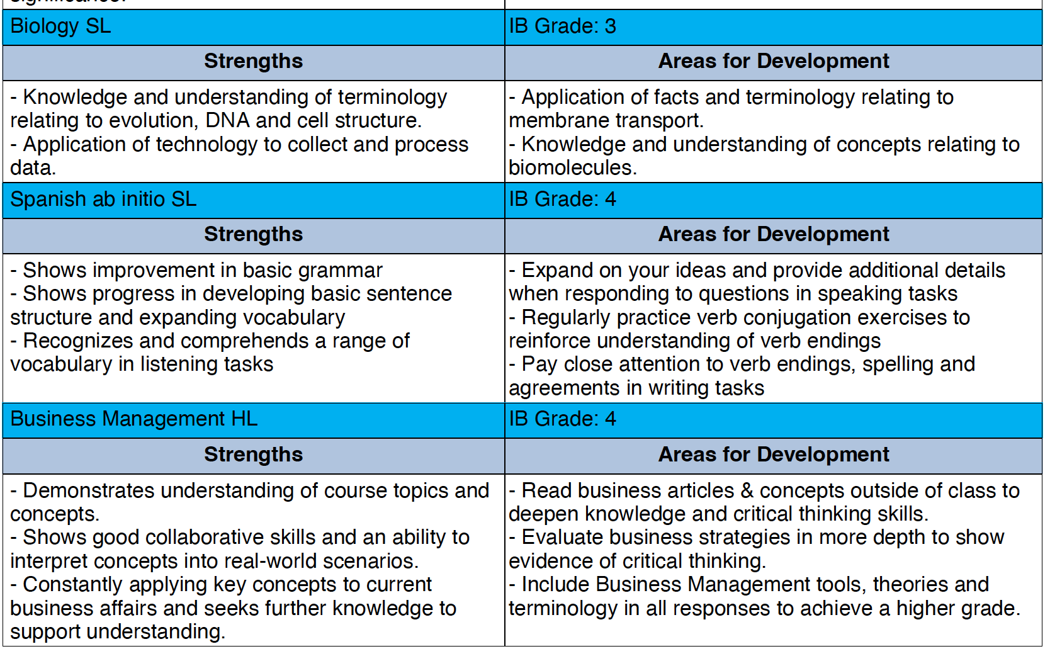
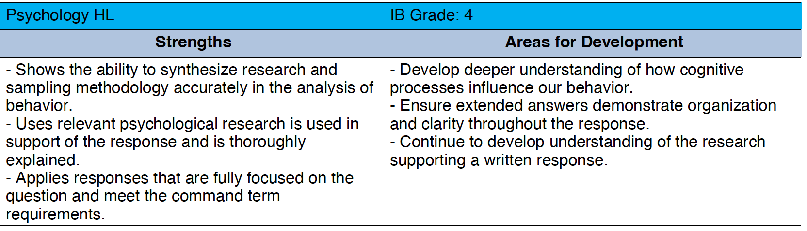

Primary Examples

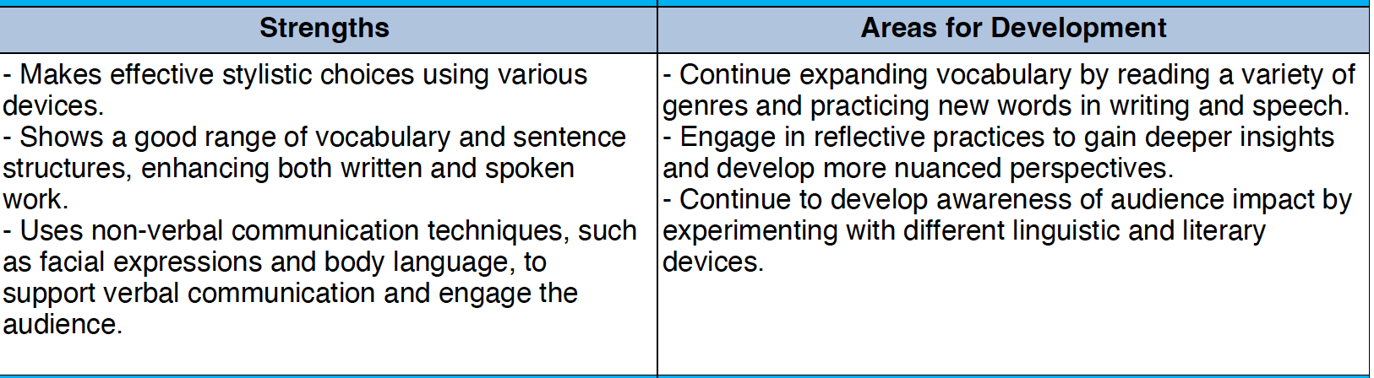

Late Assessment Process
Students are required to adhere to all deadlines for summative assessments and exams. Failure to meet these deadlines will result in a zero mark being awarded, except in the following circumstances:
Medical Reasons | Accompanied by a doctor’s note/sick leave certificate. Just an email from a parent will not be considered sufficient.
School Internal/External Competitions | Approval for absence should be obtained before the event. The subject teacher, grade leader, respective coordinator, and the Curriculum and Assessment Vice Principal should be included in the communication.
Family Emergency/Unforeseen circumstances | This must be communicated to the subject teacher, grade leader, respective stage coordinator, and Vice Principal Curriculum and Assessment. Supporting documentation may be requested.

Language of written communication:

Secondary
All in English with the exception of the following subjects,
- Georgian Language and Literature
- Georgian History
- MFL (Modern Foreign Languages)
Primary in Georgian please

